

**E-PROJECT**

**DOCUMENTATION**

***GROUP MEMBERSta***

1. HONEY.
2. MOSES.
3. WAJAHAT.
4. YASIR.
5. ARSAL.

**1.Requirement Specification**

The wesite is to be created based on the following requirments.

1. The Home Page should be created making use of Section with a suitable logo.
2. Home Page should contain details of furniture’s and home decors with suitable images.
3. The site should display a menu which will contain the options for brief introduction about the various furniture’s avavliable,location of the shop and any other information required.
4. The information should be categorized according to the brand name of the products then he/she can click on a link/button/menu etc and can see only that Brand products.
5. When a user selects any particular brand, a list of product for that brand will be displayed.
6. A brief summary of features of individual products should be displayed on the Web Page along the product but detailed Features should be store in Individual Word document which can be downloaded or viewed by the user who wishes to see the same.
7. The user should also be able to compare the various products of different as well as similar brands.
8. There should be a “Contact Us” page which will have the Address of the Company which is as follows and the mail address which when clicked will invoke the local mail client from where they can send an email.

**2.Objectives of the Project**

The Objective of this program is to give a sample project to work on real life projects. These applications help you build a larger more robust application.

The objective is not to teach you JavaScript/Dreamweaver but to provide you with a real life scenario and help you create basic applications using the tools.

You can revise the chapters before you start with the project.

This project is meant for students who have completed the module of ***Dreamweaver***. These programs should be done in the Lab sessions with assistance of the faculty if required.

It is very essential that a student has a clear understanding of the subject. Students should go through the project and solve the assignments as per requirements given.

Kindly get back @ eprojects@aptechfze.ae in case of any doubts regarding the application or its objectives.

**3.Problem Statement**

DURABLE FURNITURES is selling various types of Furniture’s. The company advertises by distributing the pamphlets, advertising on television and so on. Due to rapid development in internet field, the company decides to launch a website where people will get all the information about the various products available with them easily.

**4.Hardware/ Software Requirements**

**Hardware**

* A minimum computer system that will help you access all the tools in the courses is a Pentium 166 or better
* 64 Megabytes of RAM or better

**Software**

* Notepad/HTML editor
* Dreamweaver
* IE 5.0/ Netscape 6.0

**5.Home Page**

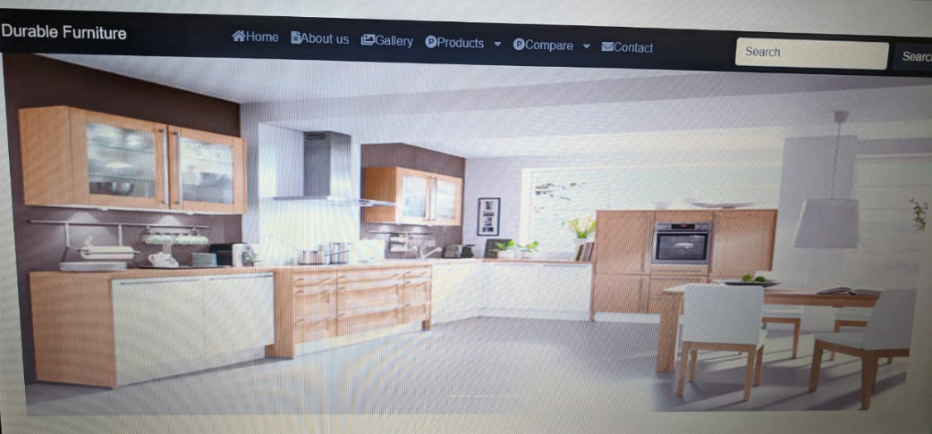

**6.Gallary**

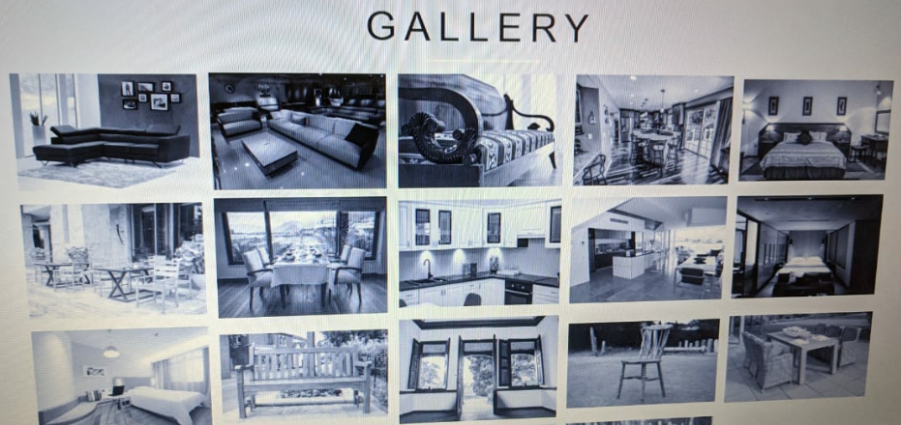

**7.About Us**

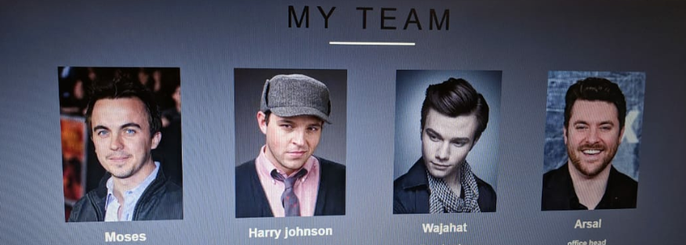

**8.Contact Us**

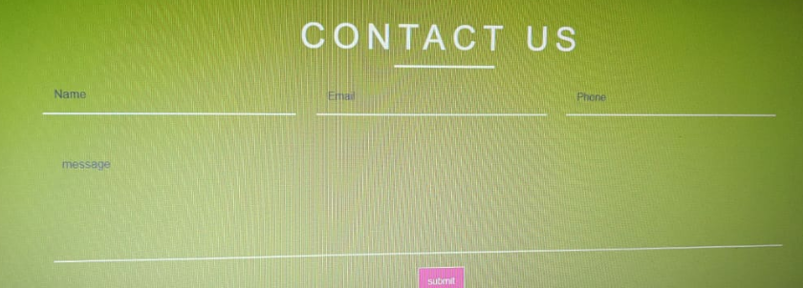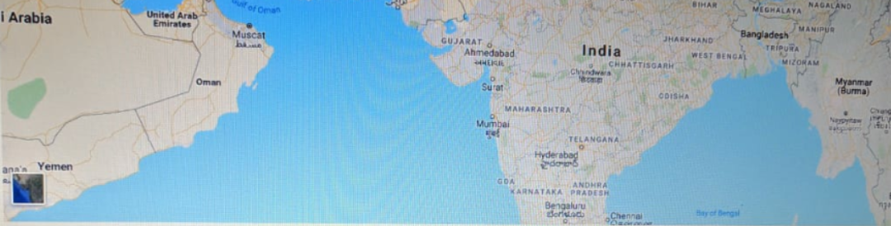

**9.Footer**

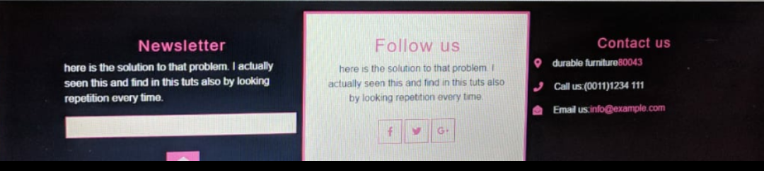

**10**.**Appendix**

**SOURCE CODE** 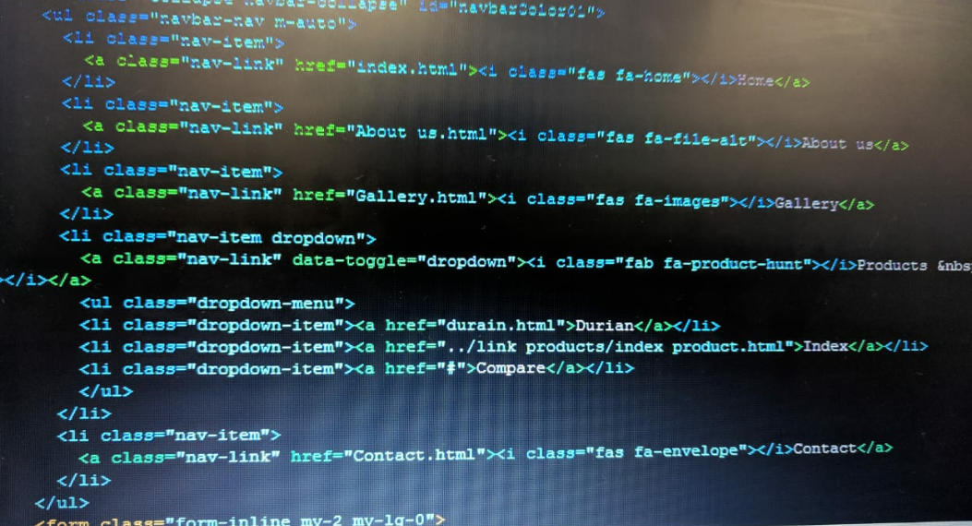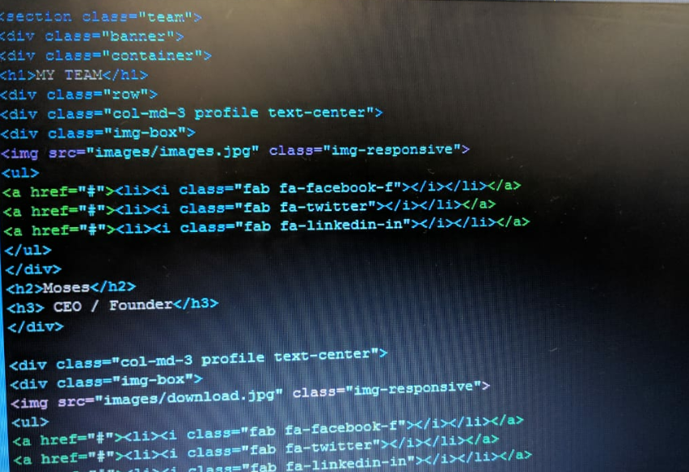

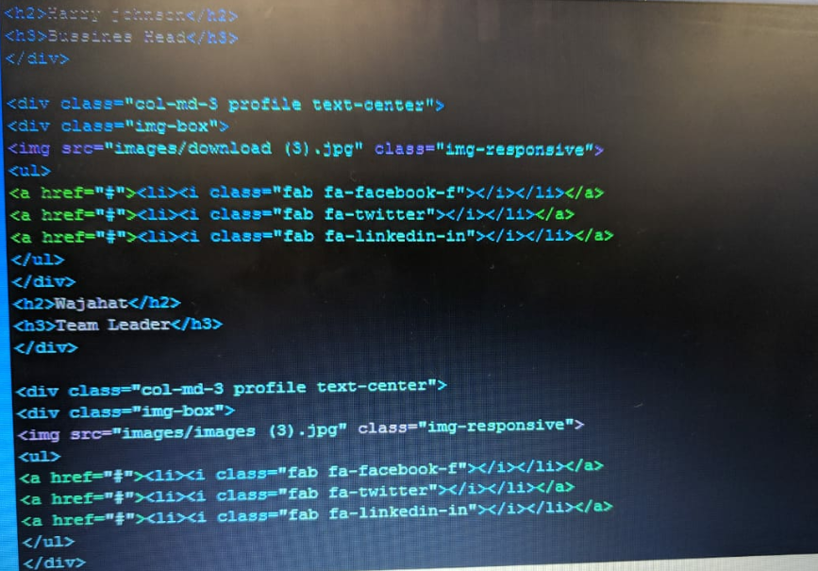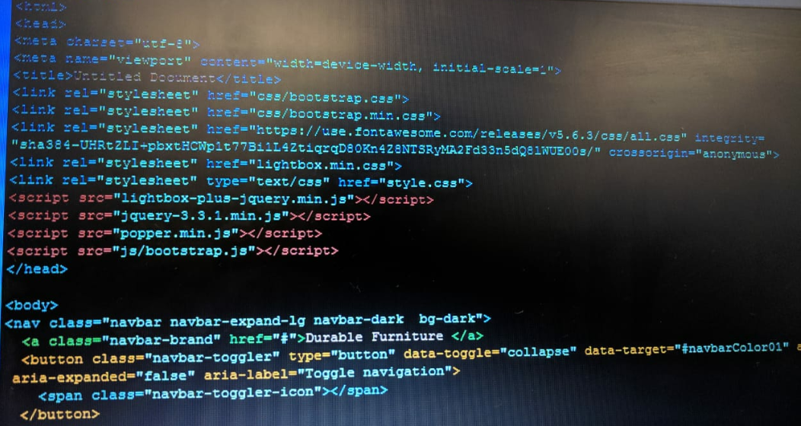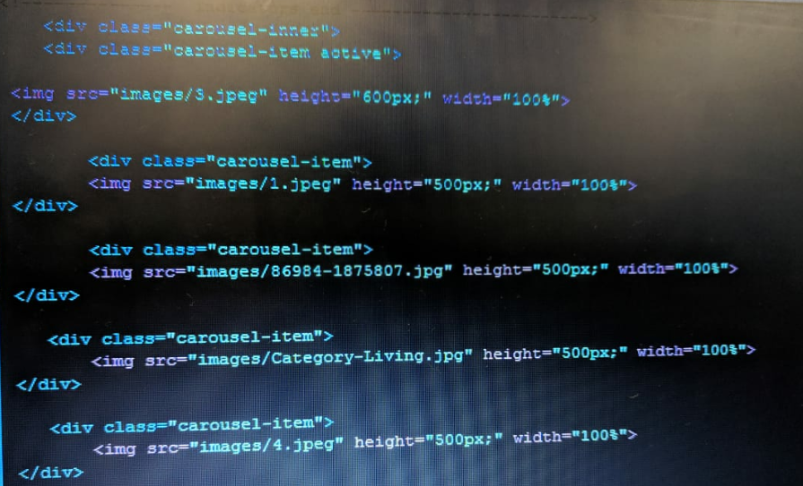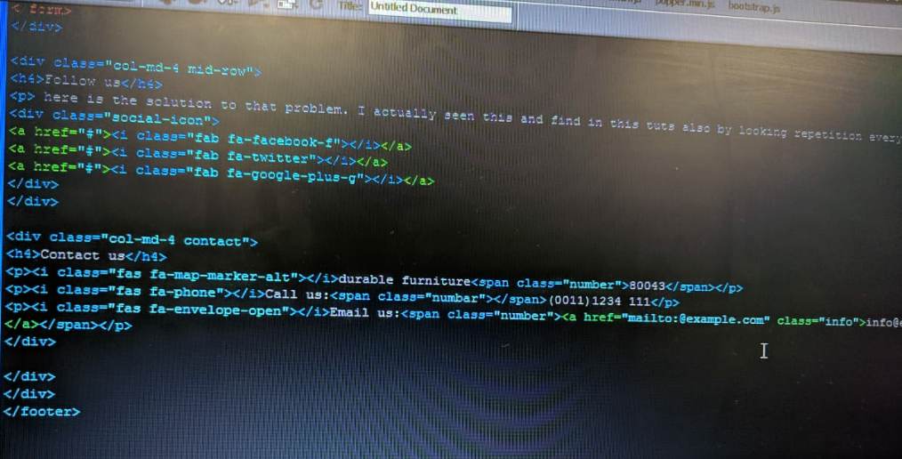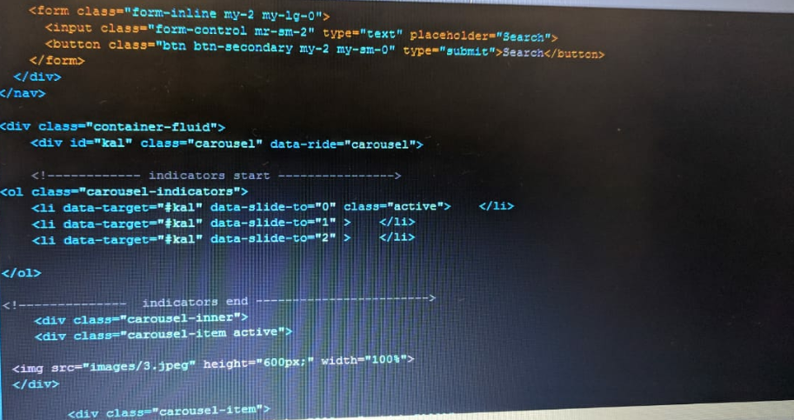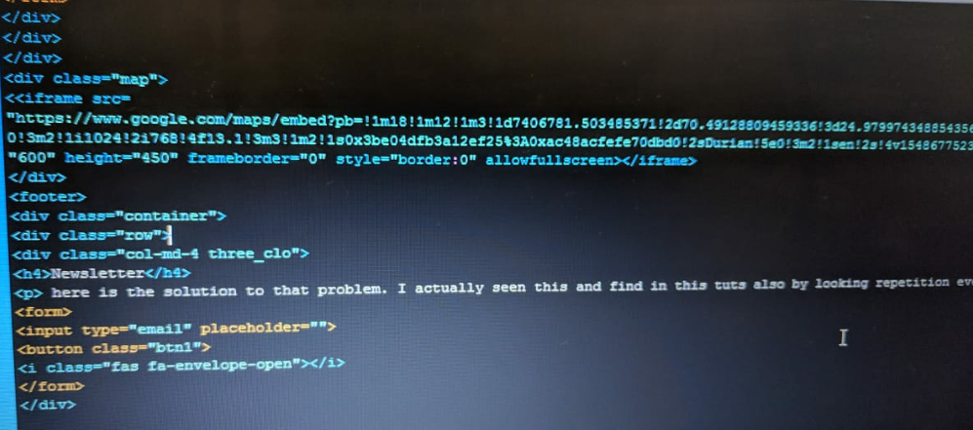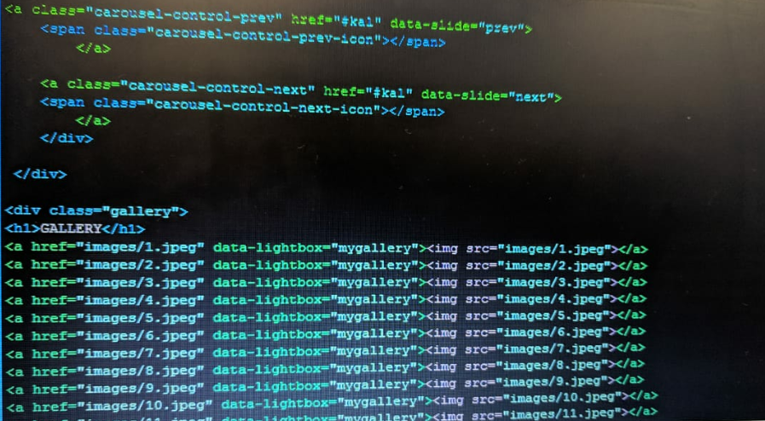

**11.Certificate**

This is to certify that

**‘HONEY’**

**‘MOSES’**

**‘WAJAHAT’**

**‘YASIR’**

**‘ARSAL’**

Has successfully designed and developed “**Durable Furniture**” which is submitted to Aptech Worldwide.

Submitted by: 29-Jan-2018

Date of Issue: 29-Dec-2019

**12.Acknowledgment**

We are thankful to almighty **ALLAH** that by His grace we have been successful. We have tried our best to take all relevant important topics in consideration so that this project may become comprehensive.

This is our first E project. We have tried our best & struggled for a better outlook to come. This project has been developed in Dreamweaver. We have been assigned to make website of **DURABLE FURNITURE** as a project. We honestly hope that this project will provide all the necessary information required for the user to fulfill their inspiration.

We would like to express gratitude to all the staff members of my Centre for not only providing opportunity to work with them on this project, but also for their support and encouragement throughout.

And we would like to express our deepest gratitude to our parents whose prayers were always encouraging to us.

And finally, many thanks to all my Group members for their valuable suggestions and constructive feedback.

********END OF DOCUMENTATION**********